ECAO3O5- SIGNALS AND SYSTEMS
NAME: S.GOKUL
REG NO: 192512373

Experiment No.: 3
Title: Energy and Power Analysis of Signals

Objective (i) To calculate the energy and average power of given continuous-time and discrete-time signals and classify them as energy signals, power signals, or neither based on their energy and power characteristics.

AIM
To calculate the energy and average power of given continuous-time signals using MATLAB and classify them as energy signals, power signals, or neither.
APPARATUS / SOFTWARE REQUIRED
1. Computer / Laboratory PC
2. MATLAB software (with Signal Processing environment)
THEORY
The energy of a continuous-time signal is E = ∫|x(t)|² dt over all time, and its average power is P = lim (1/2T)∫|x(t)|² dt as T → ∞. A signal with finite non-zero energy (and zero average power) is an energy signal; a signal with finite non-zero average power (and infinite energy) is a power signal.
The decaying exponential x₁(t) = e^(−t)u(t) has finite energy, E = ∫₀^∞ e^(−2t) dt = 0.5, so it is an energy signal. The sinusoid x₂(t) = sin(2π5t) is periodic with infinite energy and average power 1/2 for unit amplitude, so it is a power signal. In MATLAB the integrals are evaluated numerically with the trapezoidal rule (trapz).
FORMULAE USED
E = ∫ |x(t)|² dt (limits −∞ to ∞)
P = lim (T→∞) (1/2T) ∫ |x(t)|² dt (limits −T to T)
For x(t) = sin(2πf₀t): P = 1/2 (unit amplitude)
Percentage deviation = |Practical − Theoretical| / |Theoretical| × 100
PROCEDURE
- Start MATLAB and define the time vector t = 0 to 5 s with a step of 0.001 s.
- Generate the signals x₁(t) = e^(−t)u(t) and x₂(t) = sin(2π5t).
- Compute the squared magnitude of each signal.
- Compute the energy of x₁(t) by numerical integration (trapz) over the interval.
- Compute the average power of x₂(t) over an interval containing complete cycles (0 to 2 s).
- Plot both signals and display the numerical energy and power.
- Compare the numerical results with the theoretical values and classify the signals.

PROGRAM (MATLAB CODE)
% Experiment 3: Energy and Power Analysis
clc; clear; close all;

dt = 0.001;
t = 0:dt:5;

xE = exp(-t);
xP = sin(2*pi*5*t);

E_num = trapz(t,abs(xE).^2);

T0 = 1/5;
idx = t <= 2;
P_num = (1/(t(find(idx,1,'last'))-t(1))) * ...
trapz(t(idx),abs(xP(idx)).^2);

figure;
subplot(2,1,1);
plot(t,xE); grid on;
title('Energy Signal e^{-t}u(t)');
xlabel('Time (s)'); ylabel('Amplitude');

subplot(2,1,2);
plot(t,xP); grid on;
title('Power Signal sin(2pi5t)');
xlabel('Time (s)'); ylabel('Amplitude');

fprintf('Numerical energy = %g\n',E_num);
fprintf('Numerical average power = %g\n',P_num);
OUTPUT
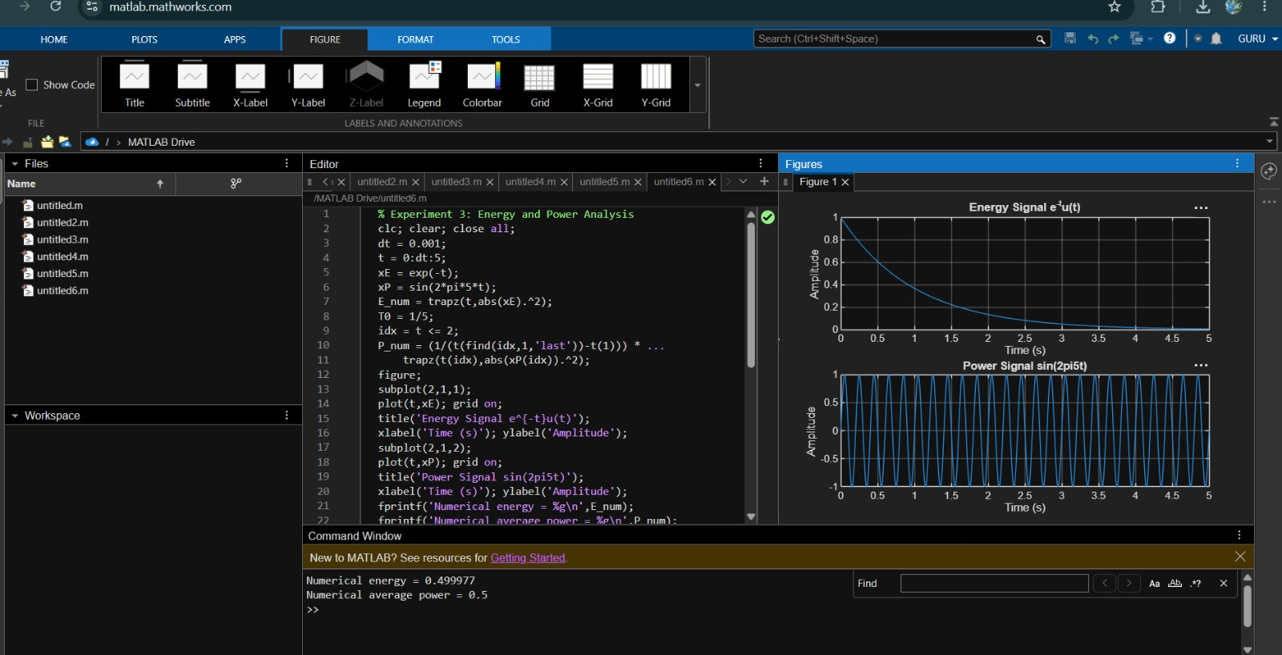
Fig. 3.1 Energy signal e^(−t)u(t) and power signal sin(2π5t)

RESULT
The numerical energy of x₁(t) = e^(−t)u(t) is approximately 0.5000 and the numerical average power of x₂(t) = sin(2π5t) is approximately 0.5000, which agree with the theoretical values. Hence x₁(t) is an energy signal and x₂(t) is a power signal.

Objective | Assessment Criterion | Excellent – 4 | Good – 3 | Satisfactory  – 2 | Needs  Improve ment – 1 | Weight age | Marks given | Marks obtained
Calculate the energy and average power of given signals | Energy & Power Calculation | Correctly calculates signal energy and average power using appropriate mathematical expressions and MATLAB  implementation  independently. | Performs calculation s correctly with minor numerical or coding errors. | Performs basic calculations but requires guidance or has noticeable errors. | Unable to correctly calculate energy or power. | 25 | 2.5
Distinguish energy signals and power signals | Signal Classificatio n | Correctly classifies signals as energy or power signals based on calculated values and theoretical conditions. | Correctly classifies signals with minor errors or limited justificatio  n. | Performs basic classification but requires assistance or provides incomplete  justification. | Unable to classify the signal correctly. | 25 | 2.5
Implement numerical energy/power computation using MATLAB | MATLAB  Implementat ion & Numerical Analysis | Develops accurate MATLAB code, obtains reliable numerical values and appropriately selects the integration/summation interval. | Code and numerical results are mostly correct with minor errors. | Implements the basic computation with assistance or noticeable numerical errors. | Unable to impleme nt the required MATLA B  computat  ion. | 25 | 2.5
Compare analytical and simulated results | Theoretical Validation & Comparison | Accurately compares theoretical and simulated values, calculates deviation where applicable and explains discrepancies  clearly. | Provides correct compariso n with minor deviations  and | Provides basic comparison but validation or interpretatio  n is limited. | Unable to compare or validate the  results. | 25 | 2.5

LABORATORY PERFORMANCE ASSESSMENT RUBRICS:

